Linux Hard Disk Recorder User Manual
(Ginseng style)

Contents
Part one Basic Operation 1
1. Basic Installation 1
2. Starting 1
3.Turn Off 1
4.Log in 1
5.Preview 2
6. Encode Setting 2
7.Recording Setting 3
8. Recording playback 6
9.Picture storage 9
10．Net work setting 9
11.Motion detection Setting 11
11.1.1 Channels and enablers 12
11.1.2 Sensitive 12
11.1.3 Region 12
11.1.4 Set the alarm period time 13
11.1.5 Time interval 14
11.2.1 Alarm output 14
11.2.3 Polling 16
11.2.4 PTZ Linkage 16
11.2.5 Send EMAIL 17
11.2.6 Show Message 17
11.2.7 Buzzer 17
12. IVS 19
12.1Perimeter alert 19
12.2 Object care 20
12.3 Human Detection 20
13. PTZ Control 21
14.Digital Channels 27
Part 2 Remote Control 29
1. WEB Remote View 29
2. VMS 29
3. Cloud server 30
4.Mobile Phone Monitoring 30
Appendix 1. Remote controller operation 31
Appendix 2.Mouse operation 32

The series DVR is designed specially for security and surveillance field which is an outstanding digital surveillance product. It introduces embedded LINUX operating system which is more stable. It introduces standard H.265 video compressed format and G.711A audio compressed format which insures the high quality image and low error coding ratio. Strong network services greatly enhance the network data transmission capacity and remote control capabilities.

Part one Basic Operation

1. Basic Installation
1.1 Hard Disk Installation
For the first use，please install the hard disk. The quantity of Hard Disk is based on requirement and specifications of the device.
Note: DVR can run and monitor normally without hard disk, while it can’t record and playback.
1.2 Mouse Connection
USB port on front and back panel, the 2 USB ports could be used for mouse, Flash stick, 3G &4G &WIFI module, mouse connection is depend on products specifications based on different products.
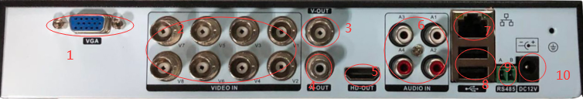
1.VGA output
2. Video interface
3.TVout (Note: need to use shielded coaxial cable)
4. Audio output
5. HDMI HD output
6. Audio input
7. Network port
8. USB interface
9.485 interface
10. Power supply (Adapter: Consumers who use a power adapter for charging should purchase a power adapter that uses CCC certification and meets standard requirements.)
11.Internal connection
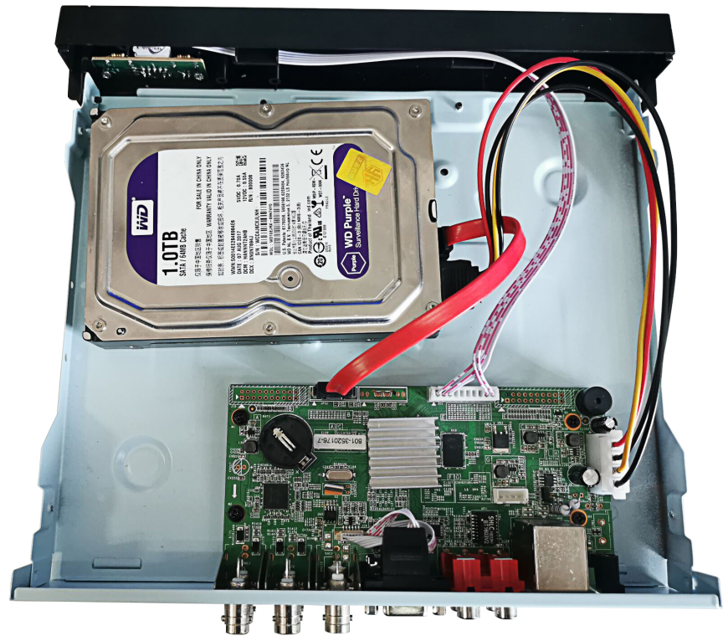
Note: Only applicable to non-tropical climate conditions!

2. Starting
Plug the power supply and turn on the power supply switch. Power supply indicator light shining indicates turning on the video recorder. After finishing the start up you will hear a beep, and the default setting of video output is multiple-window output mode.
Note: Restart the power after the abnormal power off, DVR will automatically recover the state before power off.

3.Turn Off
There are two methods to turn off the DVR which are soft switch and hard switch. Entering [main menu]>[close system]>[Close] or [right mouse button]>[close system]>[Close] or select close in the login interface is called soft switch. Pressing the power supply switch is called hard switch.

4.Log in
When the DVR boots up, user must log in and the system provides the corresponding functions with the user purview. There are two user settings which are admin and guest; and they have no passwords. “admin” is the super user purview; “guest” is the common user purview which have right to preview and recording playback. User ”admin” and “guest” can change the password, but can’t change the right.
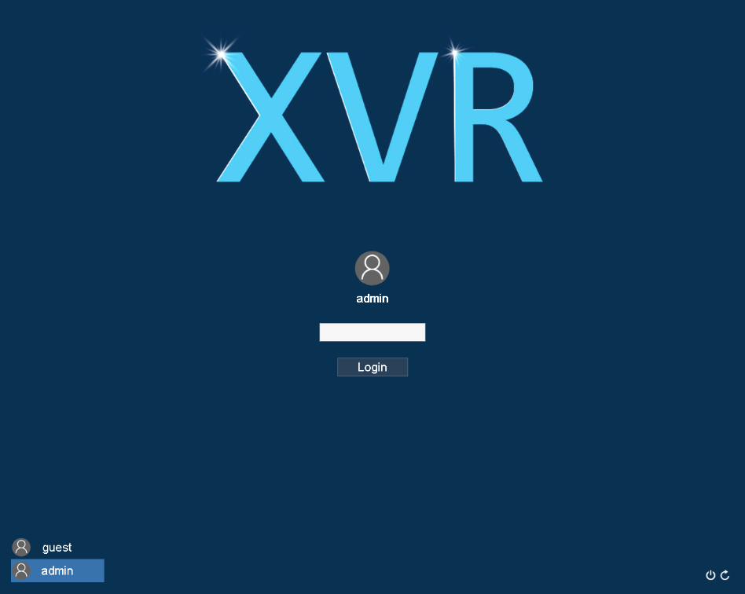
Password protection: If the password is continuous wrong five times, the alarm will start. (Through reboot or after half an hour, the account will be unlocked automatically) For your system security, please modify your password in “User management” after first login.

5.Preview
Log in normally and it will be the multiple-window preview status.
In the preview channel interface, there are preview, zoom, recording (only the devices with expanded memory can have recording function), audio icon function can be used, and date, time, channel name can also be displayed. Each screen can display the recording and alarm status of monitoring channel. The normal interface has the following icons: channel name, channel video mark, channel audio mark. When the alarm is triggered, the following alarm status signs appear: video detection, video blocking, video loss, etc alarm mark.

6. Encode Setting
Through encode setting, realize high quality playback and remote monitor function .
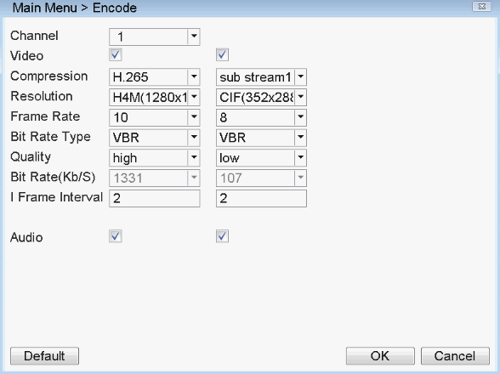
6.1 Main stream Setting
Step 1: For local operation,[ select main menu ]> [coding setting ]or [enter desktop ]> [Control Panel ]>[ coding setting];
Step 2: Select single channel, set resolution, frame rate, picture quality, code stream value, etc., for example: set coding mode to 265, resolution to 720P, frame rate to 20, code stream value to 2218 (click the default button to restore to the default setting)
Step 3: Select all channels, all channel settings can be unified, and the setting method is the same as that of single channel;
Step 4: Click [OK] and logout.
Note: 1. Reference range of bitstream value: select any resolution, and the range of bitstream value will change accordingly and corresponding; 2. After all audio / video icons are turned on, the video file will be audio-video composite stream.
6.2 Auxiliary stream Setting
Auxiliary stream is used to monitor in PC client and mobile.
Step 1: Select enable auxiliary stream;
Step 2: Configure frame rate, bitstream value, etc. the same as the setting method of single channel parameters of main bitstream.
Note: Encode resolution is different in different products .

7.Recording Setting
Recording Setting includes recording length setting, time setting, time period setting and etc. The following ways to find the interface of feature setting: [Main menu] > [Video configuration] or [enter desktop] > [video function] > [Video configuration]. Interface is as follows. Setting display in this interface，belongs to the default settings of the system.
Note: if device record normally, the hard disk installed has at least one set to read-write disk. Hard Disk Manager Reference: User Manual in CD attached with the device.
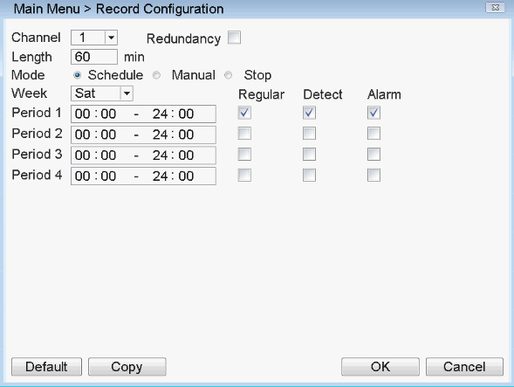
7.1 Select Channel
Method one to select channel: Left click mouse to choose the channel number, the same with all channel ,please choose “All”.
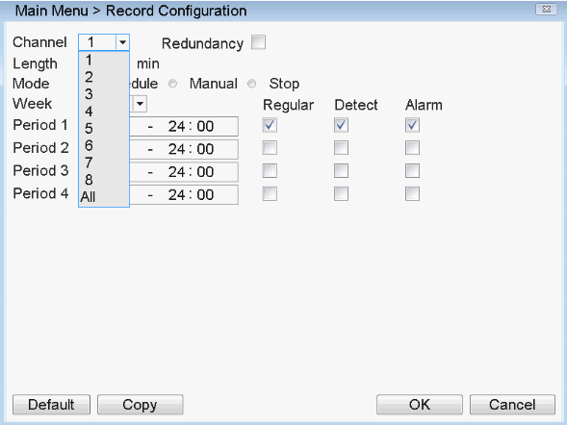
Method one to select channel: put the mouse arrow point at the channel number, and roll the roller to choose the channel number.
7.2 Redundancy
Select redundancy function, can realize recording file double backup, it says that you can backup the recording to two hard disks simultaneously. Device should be installed two hard disks, one is read-write disk, one is redundant disk.
HDD setting refer to the manual attached in CD.
7.3 Length
In normal condition (no alarm recording), each recording file will be default 60 minutes. (range 1-120 minutes)
7.4 Pre-record
Pre-record is that when the alarm signal is detected, to record a period of detection recording or alarm recording, pre-record period started from the time the alarm signal carried out before recording. For example, pre-record time is set to 10 seconds, an alarm signal is detected at 10:00， start to record the detected file, start recording time of this video is 9:59:50.
Pre-record time’ setting is to allow users to view conditions in detection range within the period before the alarm signal detected based on video detection.
7.5 Recording Function
Recording mode is divided into: manual, close, configuration
Round box 【Manual】 is displayed in “blue”, is selected , otherwise it is not selected. Regardless of the channel in any state, After selected "Manual" button , the corresponding channel record by manual and produce H format file;
Round box【Close】is displayed in "blue" , is selected, otherwise it is not selected . Regardless of the channel in any state, after selected "Close" button, the corresponding channel will stop recording.
★ Focused on the setting after choice [configuration ] mode as following:
Round box [configuration] is displayed in "blue", is selected, other wise not selected. Selected the [configuration], but also need to set [video], [time].
[Type] set the recording type, there are three types : normal, detection, alarm .
Normal: In the period settings for common video, video file type is "R";
Detection: In the period settings, trigger the " motion detection ", " video block ", " video loss " alarm signal, and the corresponding alarm function is set to open the recording function to start the " detection recording " state, the video file type is "M";
Alarm: in the setting time, trigger external alarm signal , and the " Alarm Input " function is set to open, start the " detection recording " state, the video file type is "A".
[Period Time ] to set recording time, within the period will start recording.
When you select [configuration], to set the week , the time period as following. Set up to four time periods and four time periods may be continuous, intermittent, repeated. Back each time period are ordinary, detection, alarm to select. This function will be described in an example.
Example: The following diagram interface ( select configurations, Wednesday ), the following description of the time period set in accordance with the case on Wednesday, the day of recording
00:00-3:00 within this period, only common recording, no video detection and external alarm recording. Video format is an common video format, R format.
03:00-08:00 within this period, if they have video detection alarm and linkage of the recording, the recorded video file is detected, other wise there is not any recording documents.
08:00 - 09: 00 during this period, do not record any document.
09:00-11:00 during this period, if they have an external alarm and linkage of the recording, will record alarm video, A format.
11:00-24:00 within this period, if they have video detection alarm and linkage of the video , will record detection recording , M format files , if they have an external alarm and linkage of the video, will record alarm recording, A format.
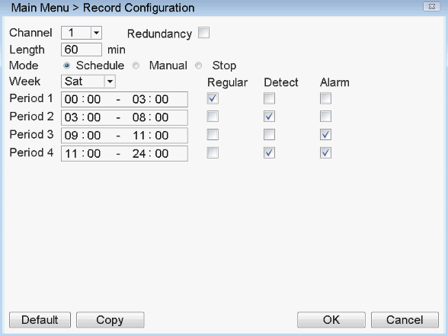
When users select the video format, according to their needs to set each channel, it is recommended to use the default (default time period is 24 consecutive hours, configuration, general, detection, alarm simultaneously selected)

8. Recording playback
Recording playback includes recording query,recording playback operation. How to open the recording playback: First: in the preview screen please click the right mouse button, then it will pop-up the menu, select [playback]; The second type: [Main Menu] > [playback]; the third type: [enter desktop ]> [playback]. Recording playback interface:
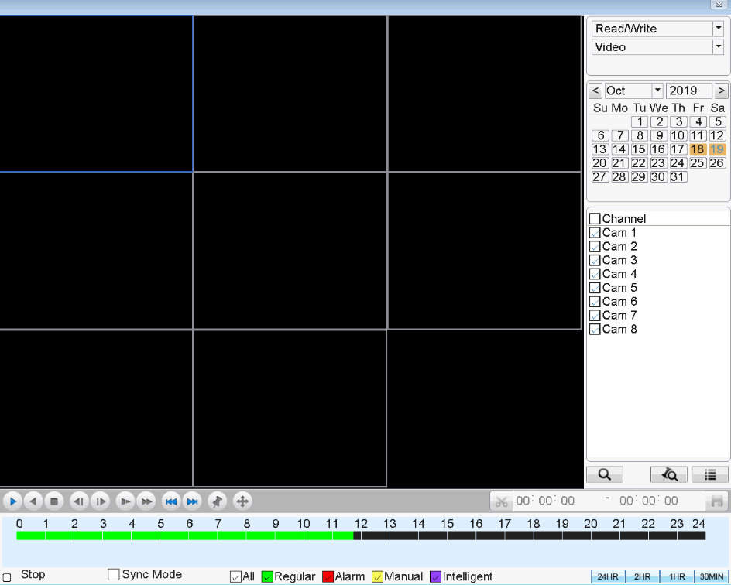
8.1 Recording query
After selecting a time period, the equipment will automatically jump to the selected time, and then click to jump to the query interface. The following picture:
When the video files are different between channels, after selecting the channel, click the query key under the channel to correctly query the video files under the channel.
[time period query]
[video mode query]
After choosing query condition,click【confirm】，If there is a recording in the input query, the recording which you query will be displayed in the recording playback interface on the right side of the list, the list can accommodate up to 128 files at most.
8.2 Recording play
You can double-click the file to play in the list, or click the play button, or select slice
playback.
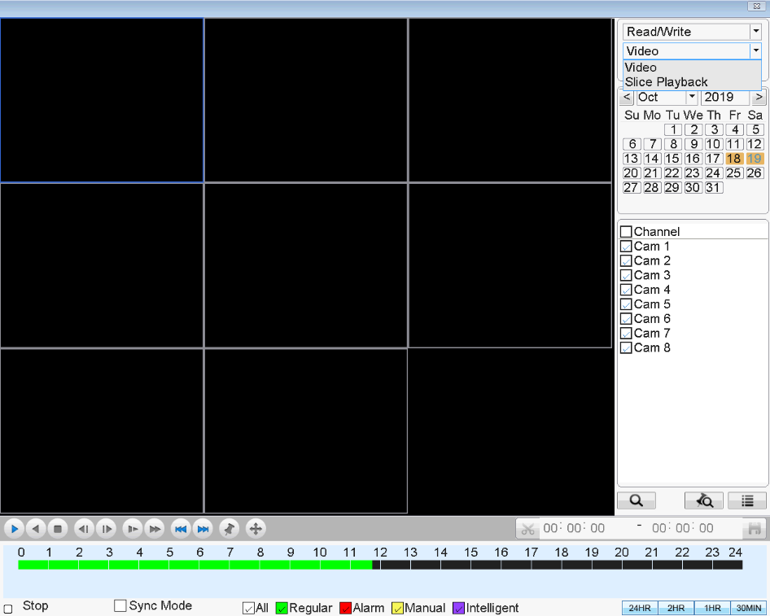
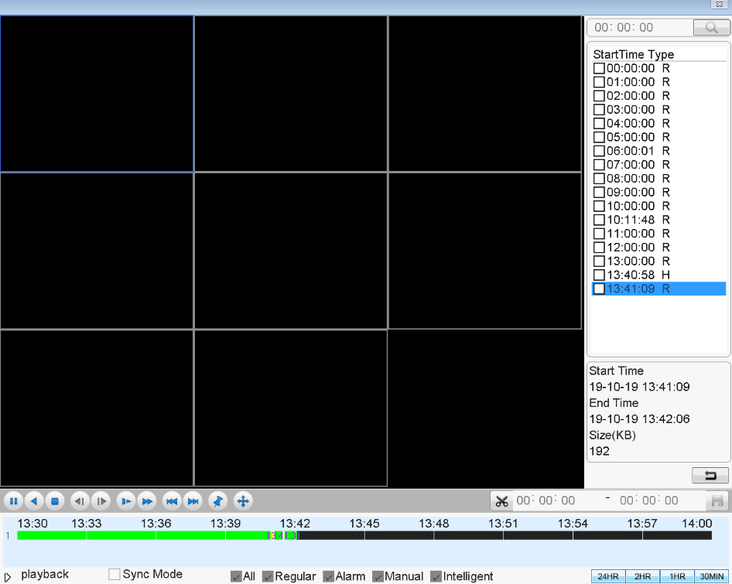
full scream | Key function
 | play
 | Inverted video recording
 | stop playback
 | slow play
 | fast play
 | Previous file
 | Next file
 | Previous frame
 | next frame
 | Full screen display
 | Label
 | shear
 | backups

"Previous frame" and "next frame" cannot be operated during playback. When the file is playing, it is gray and cannot be operated. It can only be used when the file is playing pause. It can be used for single frame forward playback and every 2 seconds back. During playback, any operation of the above keys can be performed except that "previous frame" and "next frame" cannot be operated. End playback: right click in the playback interface and [select stop playback] or [return to previous layer].

9.Picture storage
According to the settings, storage monitoring picture. This function is set according to the product specification. Parameter setting in the[main menu]>[Picture storage], and corresponding settings. The initial startup, the system is off by default.
Attention: The disk you set up need to setting a "partitioned snapshot disk" type installation disk, used to store pictures (please refer to the hard disk management).
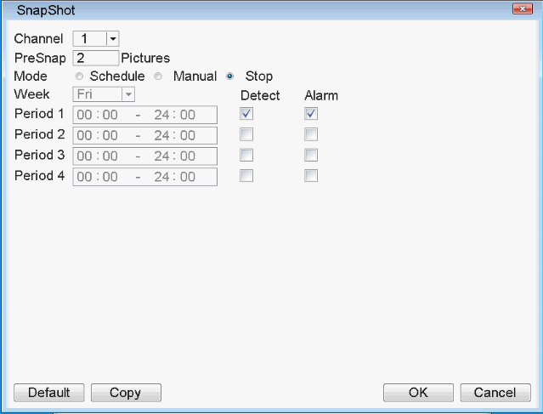
Ps: The default software without capture function

10．Net work setting
Click [Main Menu] > [network settings ]or [enter desktop] > [Network] > [network settings], set up the local network.
【IPaddress】： Set the IP address. Default: 192.168.1.18；
【Subnet Mask】：Set the subnet mask code default 255.255.255.0；
【default gateway】：Set the default gateway default 192.168.1.1。
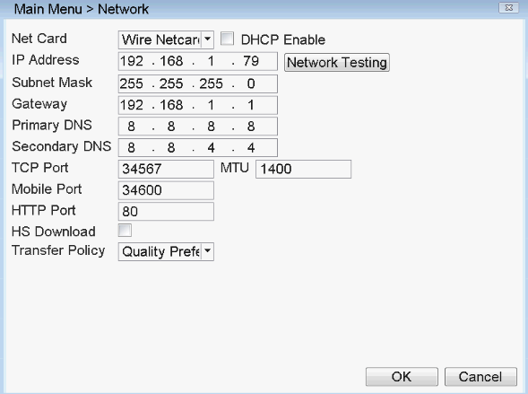
Make the equipment’s IP address and the router in the same network segment. For example, the router IP address is 192.168.1.1, and the subnet mask is 255.255.255.0. According to the default setup, generally the default gateway is the router IP address, so enter IP address 192.168.1.10 in the IE browser to achieve visiting LAN equipment such as operating image surveillance in the public network remote access equipment for monitoring. Detail setup refer to “Network setup reference”.
Enter the network service interface through [main menu] > network service] or [enter desktop] > network], as shown in the figure below. For the specific settings of each function, please refer to the corresponding instruction documents.
Dropbox: alarm video and pictures, which can be uploaded to Dropbox and viewed remotely.
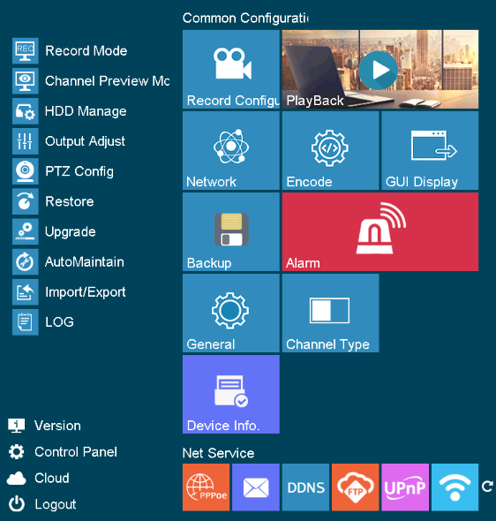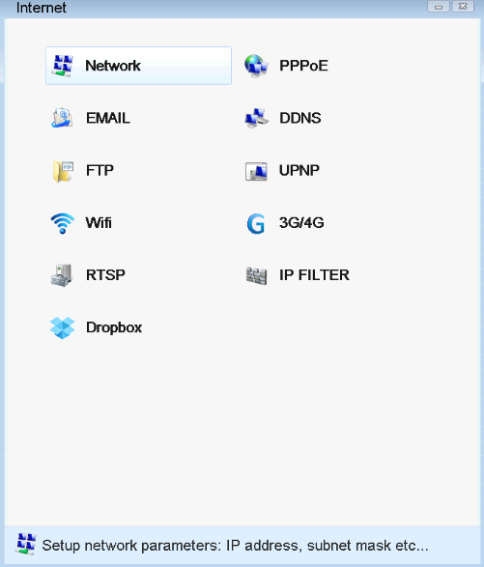

11.Motion detection Setting
The alarm function mainly includes alarm settings (motion detection, video loss, video blocking), exception handling, intelligent analysis, alarm input and human shape.Motion detection alarm setup（switch, sensitivity, detection region, disarm time interval time），it is how to setup to generate an alarm.
[alarm setting] there are three alarm settings. The function items are basically the same. Take mobile detection as an example.Find the functions setup interface in the following ways: Mobile detection settings are mainly divided into two parts:
The alarm function settings of mobile detection (enable switch, sensitivity, detection area, deployment and removal time period, interval time), that is, how to set to generate an alarm.
The linkage settings of mobile detection (screen prompt, beep, alarm output, Patrol), and some linkage settings of mobile detection that need to be combined with other functional settings (such as linkage video recording, sending email, FTP upload), that is, how to deal with the alarm.
The interface for setting this function can be found in the following ways: [Main Menu] > [alarm function ]> [mobile detection ]or [enter desktop ]>[ alarm function ]> [mobile detection]. The interface is as follows:
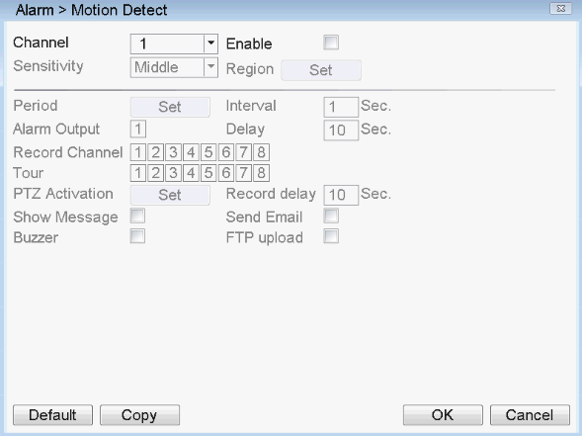
11.1 Alarm setting

11.1.1 Channels and enablers
First, select the channel to be set in the drop-down box after [channel No.]. The box after [enable] is "checked", indicating that the switch is on at the moment, otherwise it is off. Mobile detection can only be set after enabling.
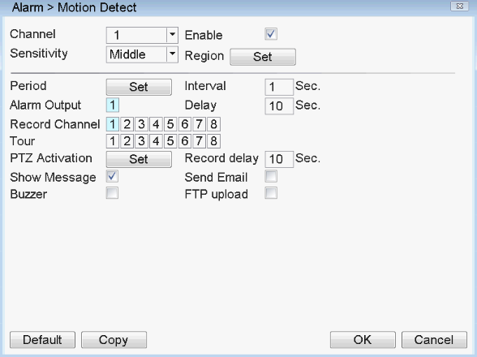

11.1.2 Sensitive
In the sensitivity dropdown box has 6 levels, it is based on the sensitivity and range of moving and intensity; lower sensitivity require higher level of moving range and intensity of the moving object. The user can drop down box select the sensitivity, the default is "middle". Suggest to sed to choose the "highest" to avoid missing the motion detection alarm.

11.1.3 Region
Click the left mouse button [region], [setup], pop-up interface, the user can press and hold the left mouse button to choose motion detection area, also can click the left mouse button to choose in the box was not continuous regional choice, the "red" display area to carry out motion detection regional, "black area" for non detection zone, after set up then quit the regional settings interface, system will save settings. Default regional settings to all the detection area, recommended to default.


11.1.4 Set the alarm period time
Click the [alarm period time] ,then click[set],pop-up interface (the default is 24 hours of testing, recommended to default, not modified). See as below picture:
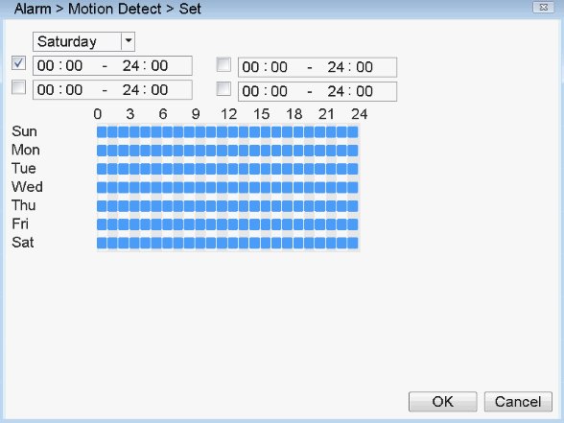
At first,choose the date you want to set in the drop-down box , then setup the time period of this date. You can set up four times at most, this four time periods can be continuous, intermittent, overlapping. It is valid when time period in front of the box is "blue", otherwise it is invalid. This is the "channel" as an example of a week removal time period setup.
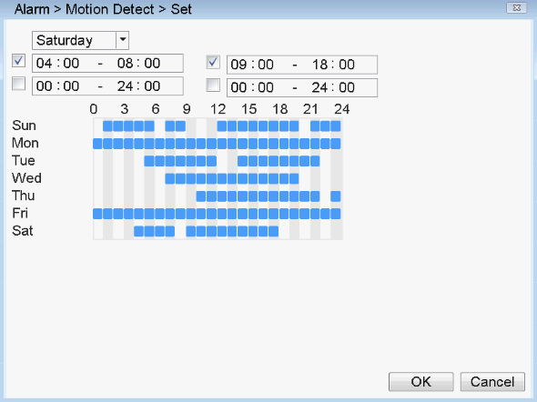
Note: the time period should be correspond the time period Gantt chart display, click the [confirm] set, save and up window. Click [Cancel], will cancel the setup this time, then up window.

11.1.5 Time interval
In the interval of time setup (default 1 second), for example, multiple motion detection only trigger an alarm signal.
11.2 Linkage setup
Linkage setup is to deal with motion setup after alarm.

11.2.1 Alarm output
When moving detection, set up corresponding linkage alarm output port of the external equipment (such as alarm), external alarm to produce the corresponding reaction equipment, after alarm output port should choose, some equipment is one of the output ports, some are two, please note which one you want to choose.When the color turn to black it is be selected, otherwise it is not selected.
The【Delay】which behind of 【Alam output】is the continuous time of the alarm output after alarm triggered. the default time is 10s. Users can accorder their own demands to set.
11.2.2 Recording chaneel
The recording channel function is when motion detective in this channel, it will begain to motion detective in the channel which be selected, and then and packaged as a file type for the M recording file.The choosing of recording channel could be one to one,also can be one to-many.Channel corresponding box be blue is be selected, otherwise it is not selected, below picture is the channel setup, channel 1(one to one),channel 1(one to-many).Generally suggest user choose one to one type.
One to one:when generate an alarm in this channel, only linkage this channel to recording.For example, picture (1),when channel 1 generate an alarm, coorsponding channel will generate linkage recording,and packaged a M recording profile.
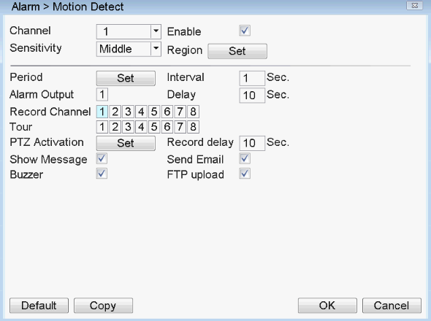
One to-many: when generate an alarm in this channel,linkage the channel you choose to recording, see below picture, when channel 1 generate an alarm, linkage the channel(2,4)to recording , packaged a M typr recording profile.
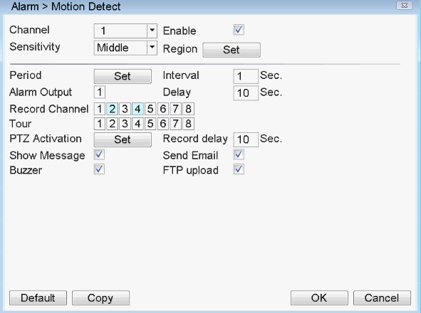
Recording delay: [recording delay]: recording delay refers to the period from the time when an alarm signal is generated to the end of the alarm, that is, the set time of [recording delay], which is 10 seconds by default. Range 10-300. As shown in the following figure, the video recording delay is set to 300 seconds: explanation: after moving objects pass, the video will be linked to generate m file, and after the alarm stops, the video will continue to be linked to delay 300 seconds before stopping.
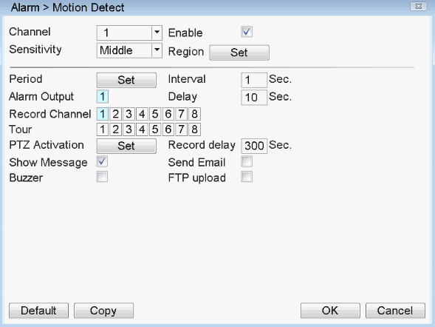
After the video channel is set, it also depends on the setting in "video configuration". If you want to record the mobile detection image, you need to set the time period of the corresponding channel here, so that the "deployment and disarming time period" is within the "video recording time period", generally select "00:00 – 24:00", and the box below the [detection] here should be selected, and saved after setting. See the video setup section for more details

11.2.3 Polling
Polling is that，the channel number in the selected channel, when there is an alarm signal, the selected channel single screen polling preview. Here you can choose any one or more channels for polling. Such as setting the figure below, choose the 1、2、3、4 、5、6 channel for polling:
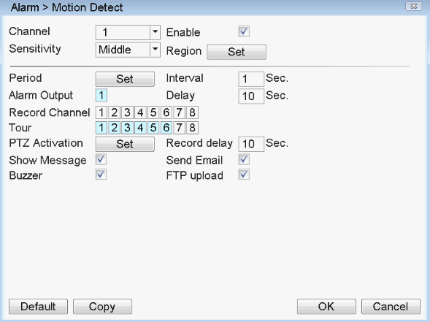

11.2.4 PTZ Linkage
When alarm occurring, set the PTZ in Channel to run linkage.
Click the setting in back of [PTZ Linkage], show the following picture:
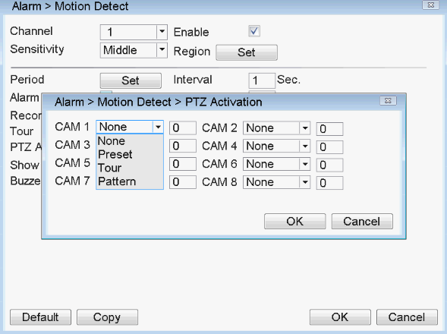
Note : For linkage of PTZ, you need to set preset point, inter point cruise, wheel cruise and other parameters in [right mouse button] > [PTZ control].

11.2.5 Send EMAIL
The box "check" after [Send Email] is checked. means that it will send email to note user when alarm occurred.
Note: To send email, you need to set it in [Main Menu] > [ EMall ] or [enter desktop] > [Network] > [EMall]. An example is shown in the figure below (using 163 mailbox)
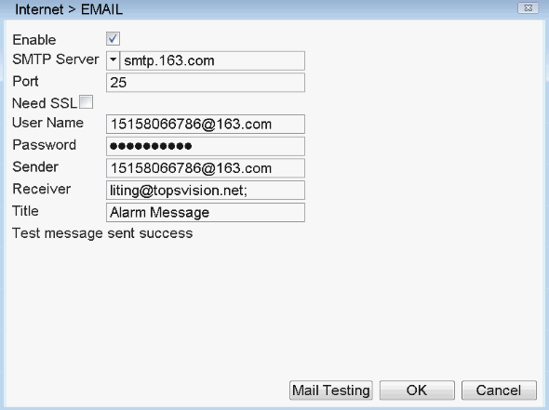

11.2.6 Show Message
Alarm State” will be shown on screen while alarm happening, and it will disappear after clicking “Sure”. (The box next to “Show Message” is black after successfully enabled, otherwise, it has not been enabled.)

11.2.7 Buzzer
The local device will be buzzing while alarm happening. (The box next to “Buzzer” is black color after enabled successfully, otherwise, it has not been enabled. )
11.2.8 FTP upload
The box "check" after [FTP upload] is checked, indicating that the alarm will be uploaded to FTP at the same time.
Note: FTP upload needs to be configured in [main menu]>[FTP] or [enter desktop]>[network]>[FTP]. At the same time, channel must be selected to generate linkage video m file. What [FTP upload] uploads to FTP is video file (the device that supports image capturing will also upload pictures, depending on the product), as shown in the figure below.
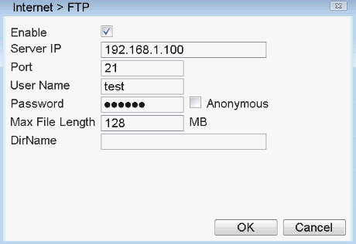
11.3 Verification
After all the above settings be done, have to check if it is working or not: select channel 1, and click to enable it, the “Period” and “Resign” just take it as default value, enable “Show Message” and “Buzzer” as following picture, and save the settings, then do some moving actions (such as waving your arms in front of the camera), if there is message shown on the screen and also buzzing, then the “Motion Detection” has been done successfully.
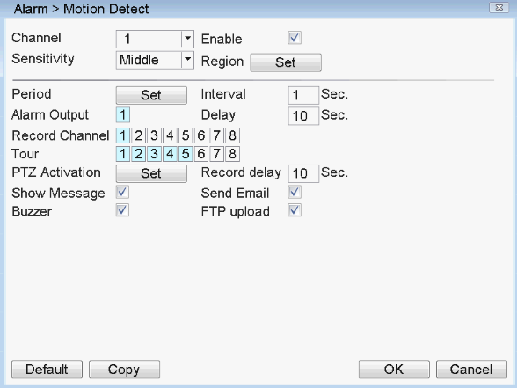

IVS

12.1Perimeter alert
Man Menu >IVS>Perimeter alert
Setting Rule:Cordon
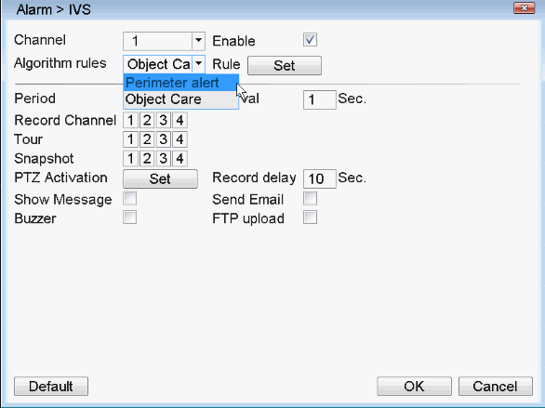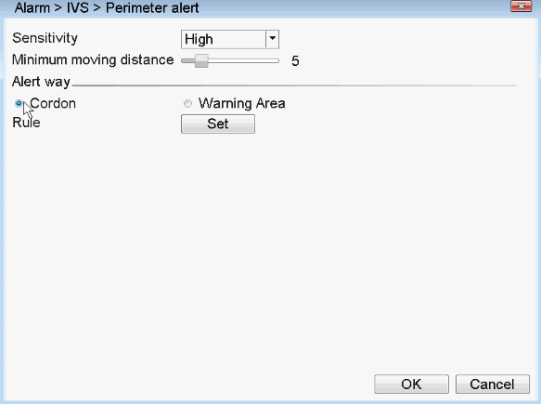
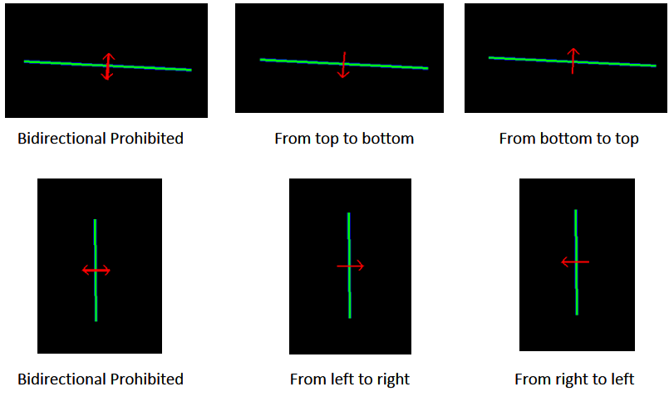
Please refer to setting 11 to setting Period time>Record Channel>Tour>Snapshot
>PTZ> Show message>Email>Buzzer>FTP
Setting Rule:Area
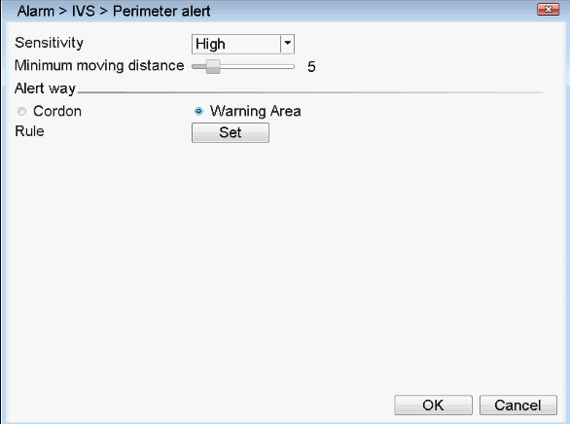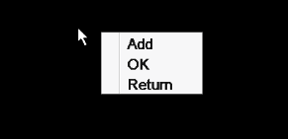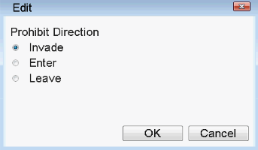
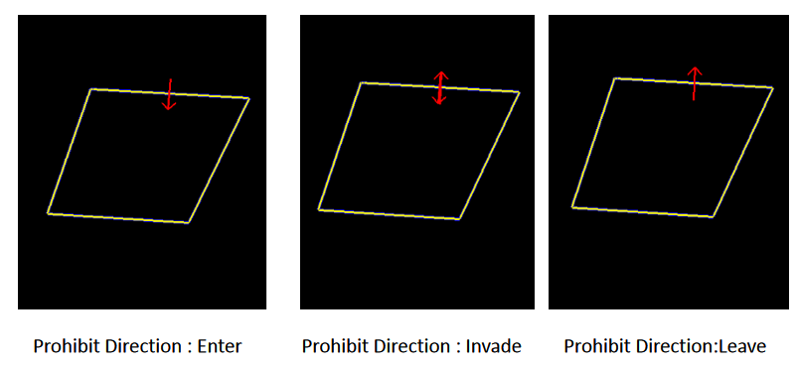
Please refer to setting 11 to setting Period time>Record Channel>Tour>Snapshot
>PTZ> Show message>Email>Buzzer>FTP

12.2 Object care
Man Menu >IVS >Object care
Setting Rule:Object left and missing
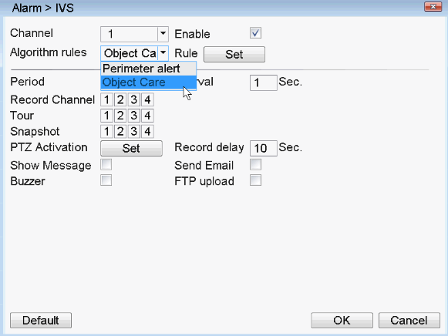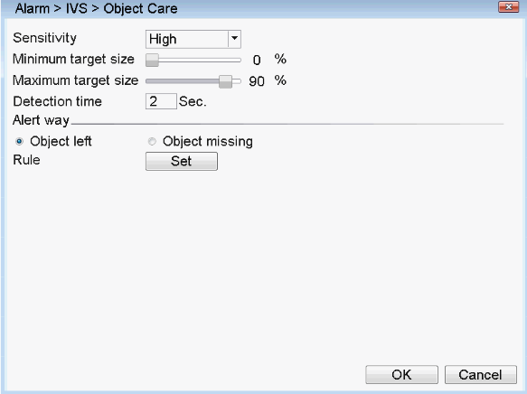
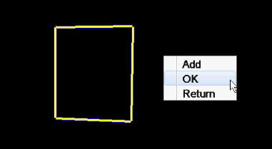
Add a area that have not object, when the object is left here,trigger alarm；
Add a area that cover the object, when the object is missing,trigger alarm.
Please refer to setting 11 to setting Period time>Record Channel>Tour>Snapshot
>PTZ> Show message>Email>Buzzer>FTP.

12.3 Human Detection
Man Menu >Alarm Function> Human Detection
Please refer to setting 11 to setting Period time>Record Channel>Tour>Snapshot
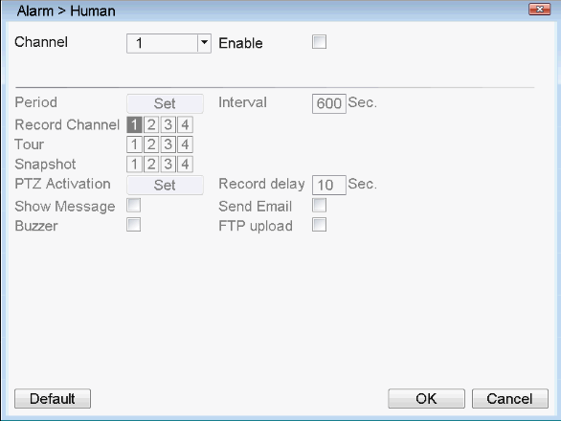

13. PTZ Control
With this function can control the direction, range, zoom, focus, iris, preset spots, cruising, light switch, horizontal rotating,etc.
To get “PTZ Control” via click the right button of the mouse over the preview interface.
13.1 Premise
1. Please make sure the connection between the PTZ dome and DVR is correct, there is “A” and “B” marked on the cables, which should be connected to the A and B port of DVR, so better to check the port first (for the position of A,B port of DVR, please refer to the Instructions included in the CD.)

2. The functions of PTZ is up to the PTZ protocol, namely, it is determined by the function of PTZ dome bought by the user.

3. Please make settings via [Main Menu] >[PTZ Config] before operation ( see following picture), which should comply with the parameters of PTZ.
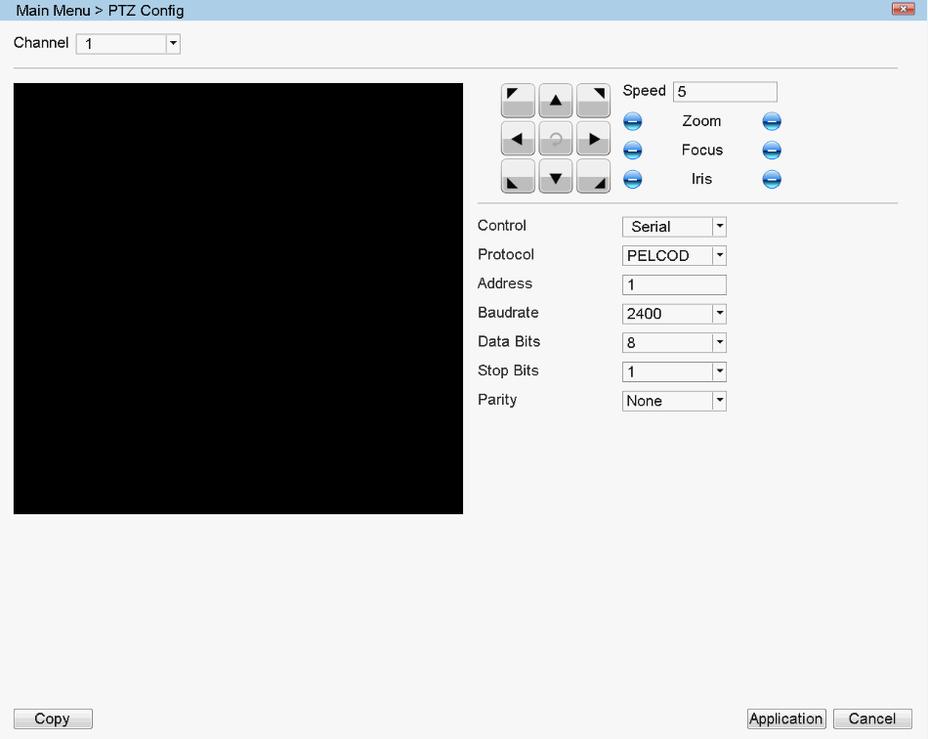
13.2 Basic Settings
The PTZ control interface is shown in the figure below
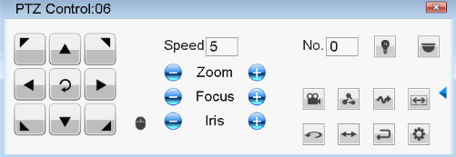
“Direction Control”, to control the PTZ rotating (8 directions).
“Speed” : to set the range of rotating (speed), the number is bigger, the range is bigger (range: 1-8)
“Zoom”: adjust via buttons /
“Focus”: adjust via buttons /
“Iris”: adjust via buttons /
“High Speed PTZ”, select it , the image of corresponding channel will be shown on the full-screen, and with left button of mouse to control the PTZ for rotate orientation; hold on the left button, and rotate the mouse wheel to adjust the magnification of camera
“Set”: Click to enter into setting menu
13.3 Function Setting
Click “Set” to enter into function control menu over the PTZ control interface. Following chart
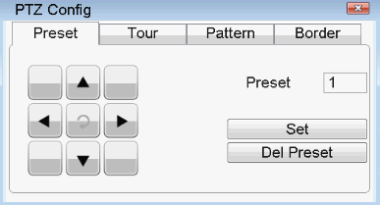
1. Preset spot
Set a location as preset, and fill the value of it, then the PTZ will turn to the preset point automatically.

1）Preset settings
Click to enter the function setting menu interface of the PTZ. The steps are as follows:
Step 1: enter the preset point "value" in the input box after the preset point (set a name for the preset point, such as 1 and 2);
Step 2: click the setting key to complete the preset point setting, that is, the preset point value corresponds to the preset point position;
Step 3: turn the pan tilt to the preset position through the direction key, and then repeat step 1 and step 2.
Clear preset point: enter the preset point "value" and click the clear preset point button to clear the preset point setting. Third, click the “Set” button to return, and complete the settings.

2）Preset call
In the figure below, enter the "value" of the preset point in the value input box, and click the preset point button , that is, the pan tilt moves to the corresponding preset point.
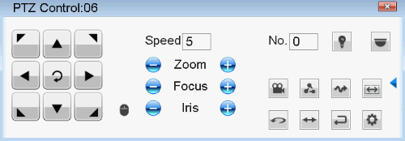
2、Cruising between spots
The PTZ runs on the cruising line, which consist of multiple preset spots.
1）Cruising settings
Click to enter the function setting menu interface of the PTZ, and the setting steps are as follows:
Step 1: set several preset points in the same way as the above preset point setting steps;
Step 2: click the inter point cruise button, input the preset point value set in the preset point dialog box, click the add preset point key, that is, set the specified azimuth as one of the preset points for inter point cruise; enter the cruise line value in the cruise line dialog box
Clear preset point: enter preset points, click Clear preset point to clear the preset point setting.
Clear cruise line: input the number of cruise lines, click the clear cruise line button to clear the cruise line point setting.
The inter point cruise setting interface is as follows
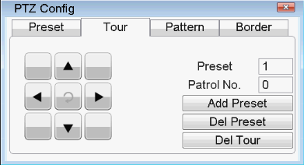
2）Cruise calls
In the figure below, enter the cruise value between points in the value input box, and click the cruise button between points , that is, the PTZ operates repeatedly on the cruise route.
3、Trace
To set a trace line via PTZ control, and take it as cruising line to make the PTZ run on it.
1）Trace set
Click to enter the function setting menu interface of the PTZ. The steps are as follows:
Step 1: click the "track Patrol" button to enter the track patrol function setting interface;
Step 2: input the value in the box after the trace inspection, and click the start button;
Step 3: enter the PTZ control interface to perform a series of operations such as zoom, focus, aperture or direction;
Step 4: return to the track inspection function setting interface and click the end key to complete the setting, that is, the track inspection value corresponds to the corresponding route.
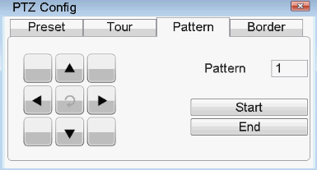
2）Trace calls
In the figure below, enter the number of traces in the value input box, and click the trace patrol button  , that is, the PTZ operates according to the set route, and click the direction key to stop.
4、The boundary line scan
In the horizontal line, set a route, start the line scan, PTZ will run repeatedly according to the route set.
1) Line scan settings
Set a horizontal arc as the track of PTZ search, as follows:
Step 1: in the PTZ control interface, control the direction key to turn the PTZ to the specified direction, click the setting key to enter the PTZ setting interface, select the left boundary, and return to the PTZ control interface;
Step 2: control the azimuth key to select the specified position, click the setting key to enter the PTZ setting interface, select the right boundary point, and return to the PTZ control interface;
Step 3: complete the setting, that is, set the position to the left boundary and the right boundary.
Note: the left and right boundaries are in the same horizontal line, and will rotate circularly from the left boundary point to the right boundary point according to the rotation of the PTZ from the left boundary point in the opposite direction; the left and right boundaries are not in the same horizontal line, and the PTZ only takes the end of the horizontal track line connected with the left boundary point as the right boundary point, and rotates circularly from the left boundary point to the right boundary point in the opposite direction.
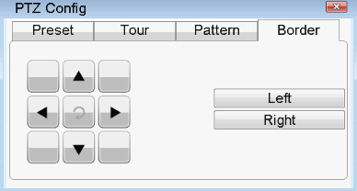
2) Line scan enable
In the figure below, click the line scan button 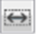 , that is, the PTZ operates according to the set route.
5、Horizontal Rotating
Click the horizontal rotate button, the PTZ will rotate horizontally (take the original position to rotate horizontally), click “Stop” to cease the movement.
6、Reversal
Click the horizontal rotate button, the PTZ will reverse.
7、Reset
Reboot the PTZ, and all the settings will be 0.
8、Page Switch
In the PTZ control interface, click the auxiliary switch button to enter the figure below to set the auxiliary functions. Auxiliary number corresponds to auxiliary switch on decoder
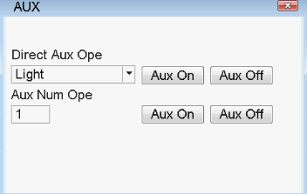
[intuitive auxiliary operation] select the auxiliary equipment, select the on / off button to operate the switch;
[Auxiliary number operation] operate the corresponding auxiliary switch according to the PTZ protocol;

14.Digital Channels
14.1 Adding IPC
Adding IPC has two methods.
One is added through [main menu] > [camera management], as shown in the following figure.
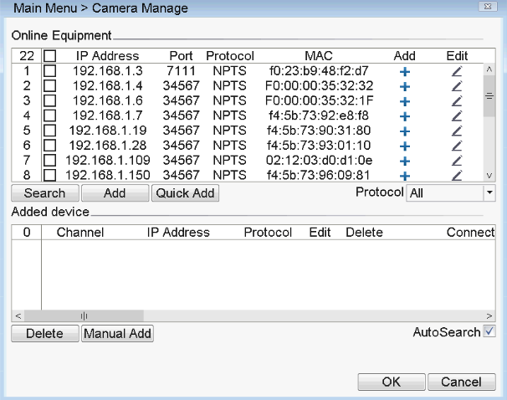
[Search] search IPC on line in LAN.
[Add] choose IPC in the search box to add.
[delete] delete added IPC.
[Edit] modify the IP address of the IPC in the search list box.
[Manual Add] input IP address, port, user name and password to add IPC.
[IPC Pnp] when choose IPC Pnp, it will automatically add the IPC on line.
The other method: click  on the preview screen, it will pop out the following interface.
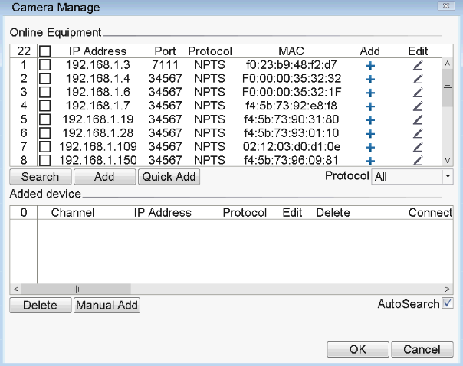
Select the IPC to add and double-click.
14.2 Remotely set IPC
Double click added IPC, it will appear the interface as below.
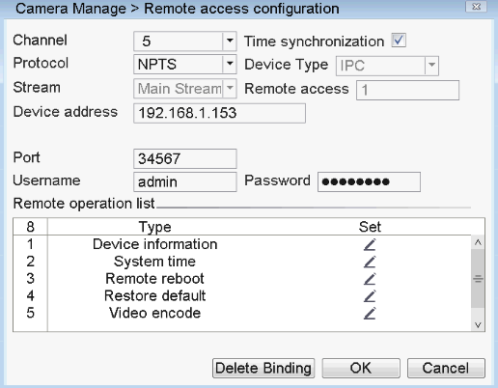
[Device information] check out the basic information of IPC.
[System time]check out IPC time, put the IPC time synchronous to local.
[Remote reboot] remotely reboot IPC.
[Restore default]Restore IPC default setting.
[Video encode]set IPC video encode parameters, like resolution,frame rate,bit rate.
[Color settings] adjust image brightness, contrast, saturation.
[Delete binding]delete connected IPC.
[Device name] can modify the name of IPC.
[System upgrade] can upgrade the IPC program.

Part 2 Remote Control

1. WEB Remote View
1.1 Web Log in
After the network is connected, use the browser of PC to log in DVR device for remote monitoring. Please refer to the instructions of web2.0 client for specific operation.
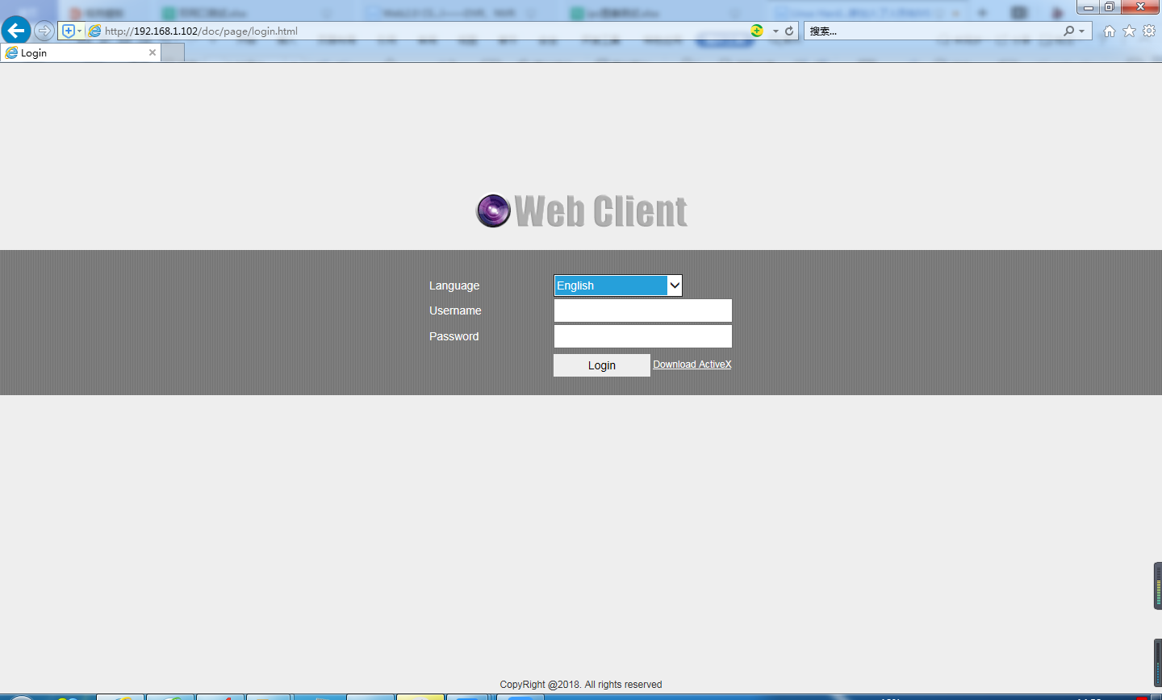
Web login interface
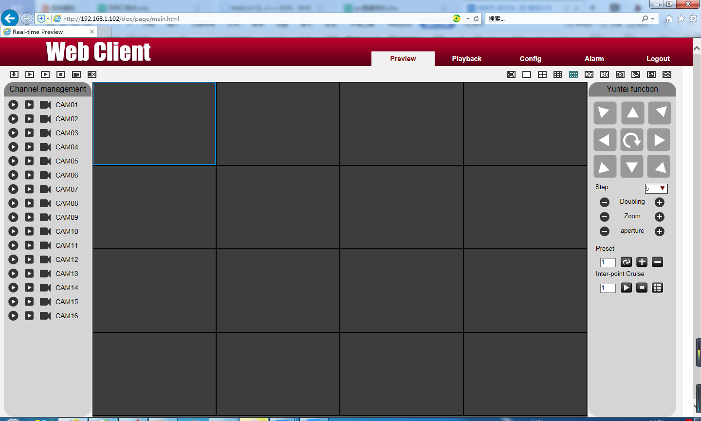

2. VMS
VMS software is used in a computer, and manipulates several device at the same time.
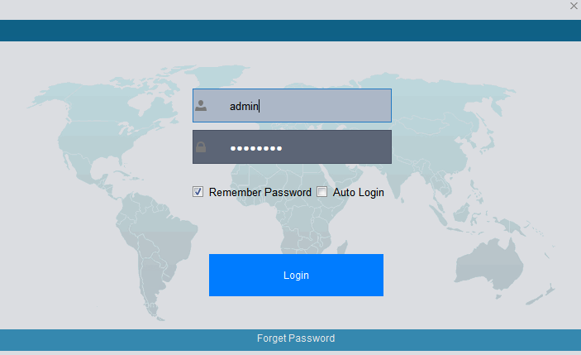
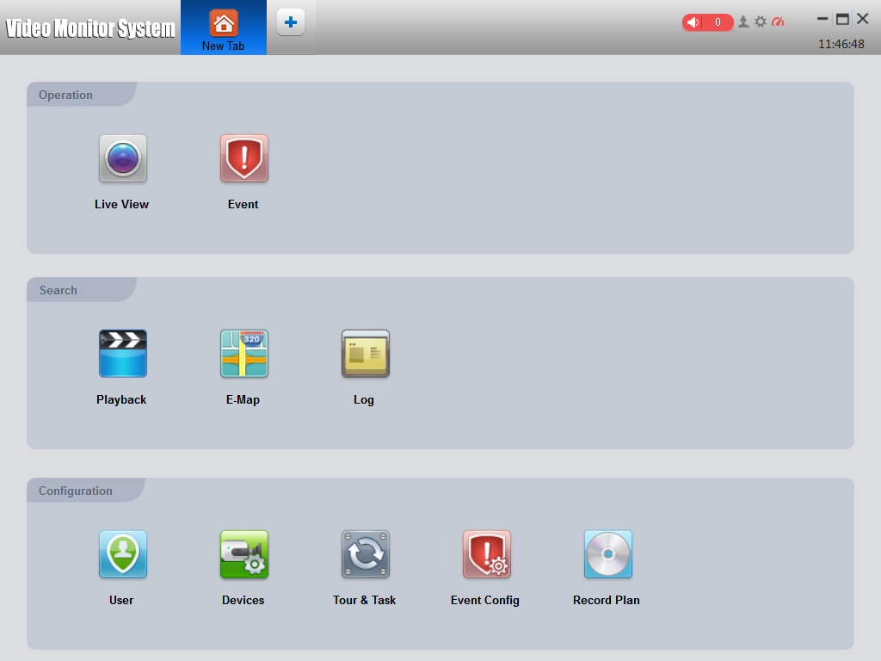
- Cloud server
By Cloud server, no mapping port, only need device ID, then you can remotely access the device directly. For more details please refer to Cloud server user manual.
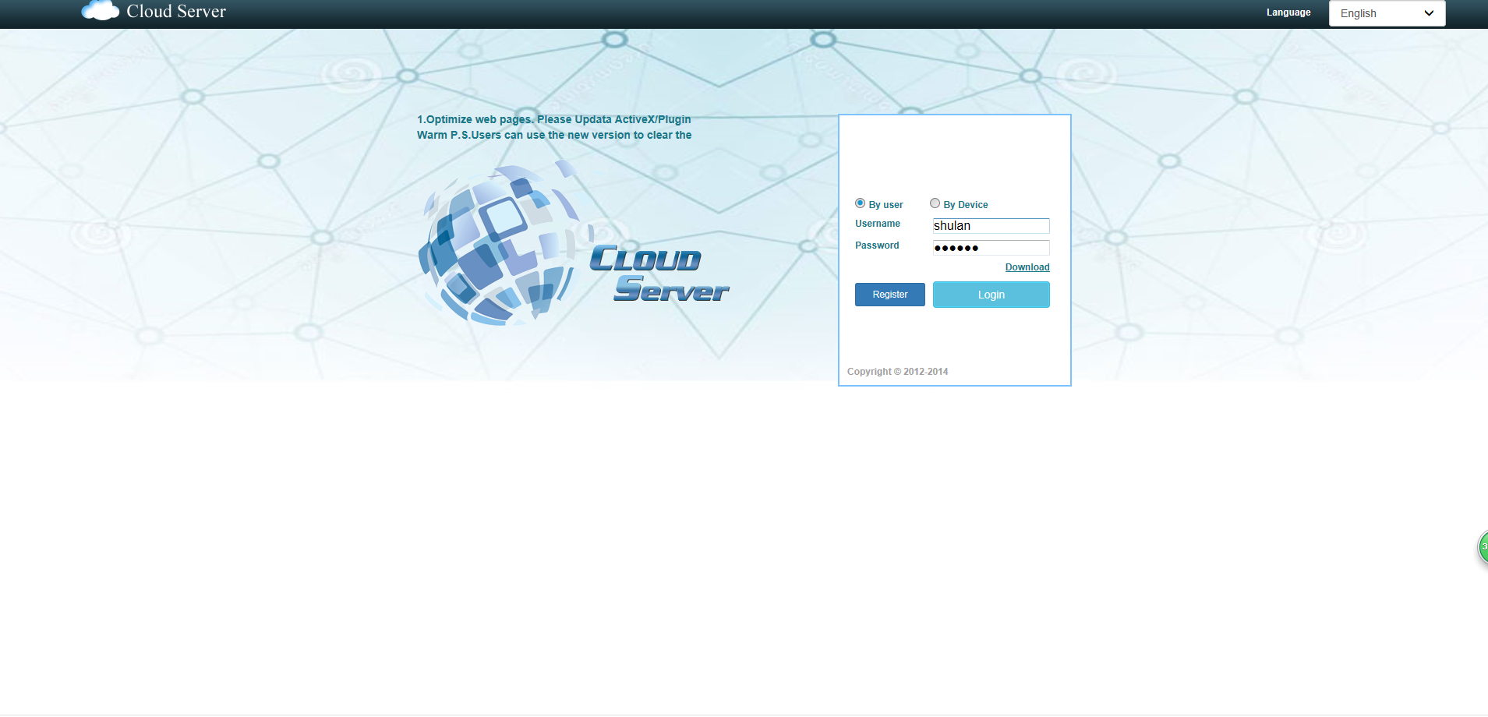
Log in interface

4.Mobile Phone Monitoring
The monitoring function of mobile phone is enabled by default.
Mobile monitoring software: XVRView, the mobile monitoring port is 5800.
For details, please refer to the user's instructions of mobile client.

Appendix 1. Remote controller operation

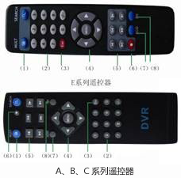
Serial number | Name | Function
1 | Multi-channels button | Multi-channels preview
2 | Number button | Password input/number input/ channel switch
3 | 【Esc】 | Back to up window
4 | Direction button | Direction and OK button
5 | Playback operate | Playback Basic operation
6 | Record control | Enter into record menu
7 | Remote controller | Input the number of DVR to control it
8 | FN | Assistant function

Appendix 2.Mouse operation
*Take right hand as an example

Operation | Function
Double left click | Double click one item in the file list to playback the video  Double click the playback video to zoom in or out the screen
Double left click | Double click the channel to make it full screen display in preview  double click again to resume the multi-channel display
Left click | Choose according option in the menu
Right click | Pop desktop shortcut menu in preview state
Right click | Current shortcut menu in the menu
Wheel button | Add or subtract number value in the number setting
Wheel button | Switch the items in the combo box
Wheel button | Page up or down in the list
Move mouse | Choose the widget or move the item in the widget
Drag mouse | Set the motion detect area
Drag mouse | Set the cover area

Thank you for reading, if you have any questions please contact us.

